**ARTICLE**

**Glasswing butterflies increase the power output of solar panels**

Katie Shanks1, Paul W Leu2 and Richard H. ffrench-Constant3

_____________________________________________________

1Environment and Sustainability Institute and 3Centre for Ecology and Conservation, Biosciences, University of Exeter, Falmouth, TR10 9FE, UK.

2University of Pittsburgh

**Abstract**

* Need for green energy, need for integration into point of demand=solar
* Intermittency, sun

**The growth of solar PV applications:**

A key to reducing the use of fossil fuels and lowering their carbon emissions into the atmosphere is the adoption of more renewable energy technologies. These technologies address climate change issues and provide for energy independence and security. Among different renewable energy sources, solar energy is widely abundant, scalable, versatile, low-cost, low environmental impact, and provides for decentralized energy generation. Solar technologies have matured and become more affordable in the market, resulting in on-grid and on-grid and off-grid PV systems dominating the share of renewable energy growth. PV is experiencing rapid growth as governments, private companies, and utility providers increasingly recognize the value of solar energy as a clean, renewable, and cost-effective energy source. Solar installations have been growing exponentially and as of 2020, approximately 760 GW (0.76 TW) of solar PV has been installed globally [1]. However, to achieve carbon reduction and net zero targets [1], [2], continued exponential growth of installed solar PV capacity is required. This growth must culminate in an estimated total of over 12.5 TW of installed capacity by 2050 [1], [3] with some projections suggesting up to 57.6 TW [1] will be required.

The widespread deployment of PV installations encompasses a wide range of applications, such as residential and commercial building structures, which include vertical wall/window and roof installations [4]–[7]), as well as utility-scale PV arrays. Moreover, transportation infrastructure such as trains and electric vehicles [8], along with their charging stations are also adopting PV technology. Agrivoltaics, or agrophotovoltaics, is an emerging field that focuses on combining agriculture and PV energy generation and being increasingly adopted by farm-owners. With the rise in PV installations, there is tremendous interest in improving the solar power conversion efficiency of PV modules. Increased efficiency in PV modules leads to a reduction in the overall cost of PV systems, as more electricity is generated per area. The ability to utilize less area is especially important in urban areas and helps reduce the environmental impact of large-scale installations. Towards the goal of improving the overall efficiency of PV modules, there has been much research and development efforts into bifacial PV panels and tandem PV cells. Other research is needed to continue to improve PV power conversion efficiency.

**Multi-functional anti-reflection coatings:**

PV modules typically use glass as the topmost front cover to protect the PV cells and other components from environmental factors. The glass contributes to the structural integrity of the PV module and ensures its durability by protecting it from the elements. Ideally, the glass must have high resistance to weather such as extreme temperatures, ultraviolet (UV) radiation, humidity, and physical damage such as hail or debris. In addition, the glass should maximize light transmission so that sunlight reaches the solar cells and can be converted to electricity. Towards this goal, there has been much interest in anti-reflective (AR) coatings for solar glass to improve the annual energy generation of PV modules. AR glass typically consists of a quarter-wavelength thin film of dielectric or porous silicon dioxide with an index of refraction with the geometric mean of air and glass to reduce the reflection between the glass and air.

While thin films provide for low reflection at a single wavelength at normal incidence, PV glass must provide for AR across a wide variety of wavelengths and incidence angles. PV glass must provide for AR in the UV, visible, and near-IR. Furthermore, the great majority of solar installations are fixed tilt instead of tracking. This is because fixed tilt installations provide for simplicity, lower upfront and maintenance costs, reliability, space efficiency, and wide applicability to various environments. Fixed tilt installations not only do not track the sun, but they are often mounted at sub-optimal orientations as they use existing building structures such as the roof. Thus, PV glass must provide for AR across a wide variety of incidence angles.

Towards the creation of new AR structures, scientists have looked toward biomimicry of natural materials for inspiration. Solar cell absorption efficiencies have been improved via biomimicry of moth eye nano-patterns [10] but there are many further optical nanostructures within nature yet to be investigated for solar energy applications [11], [12]. Haghanifar *et. al.* have developed a method of etching glass to replicate the highly anti-reflective, super hydrophobic, and durable wing nanostructures of the glasswing butterfly [13]. The wings of the glasswing butterfly have an impressively low reflectance of < 2.2% over the wavelength range 200-800nm for angles of incidence (AOI) up to 65° as reported by Siddique et. al [14]. The AR structure of the glasswing butterfly and the developed etched glass nanostructure mimicking its properties provides for broadband and omnidirectional AR, which suggests that it may be beneficial for fixed tilt PV installations. Here we analyze and compare the nanostructure designed by Haghanifar *et. al.* to other AR coatings and model the annual energy yield if applied to standard flat plate solar panels in different locations and orientations.

**Glasswing anti-reflection nanostructure:**

In this study we extend the understanding of the optical properties of the wings of the great-oto (glasswing) butterfly. Our research builds upon the research carried out by Siddique *et. al.* [14], by extending the reflectance and transmittance measurements to a wavelength of 1600 nm. This wavelength range includes the response range of multi-junction solar cells, where higher reflectance is seen, as shown in figure 1A and compared with 1 mm thick glass. Reflectance from the front and back surface of the wing leads to thin film interference that can be seen in the reflectance result of the glasswing sample (figure 1A) [15]. We also measured the transmittance spectra of the wings of the glasswing butterfly and compared it to different thicknesses of glass (figure 1B) as this affects the absorption through the materials. The wing samples are very thin, but we have included a comparison to 100 micrometer glass as shown in figure 1B.

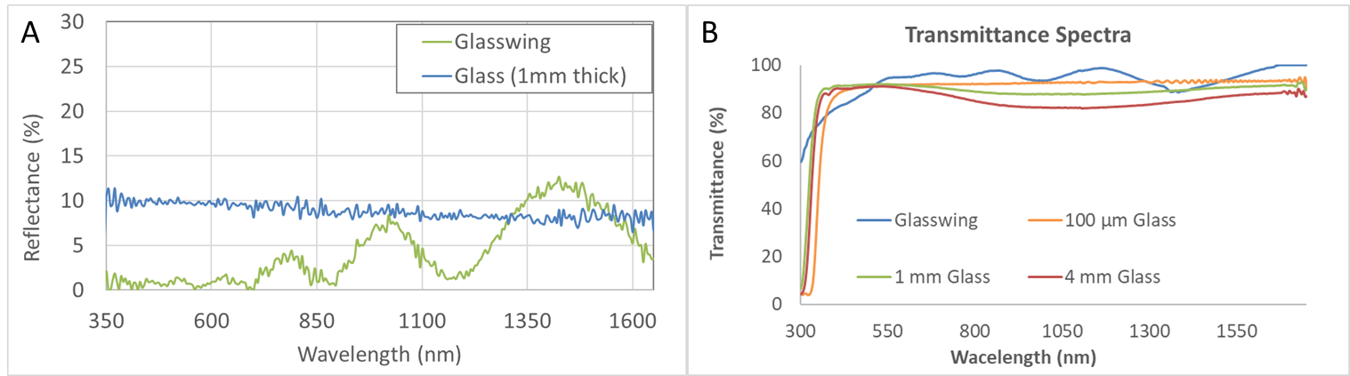

Figure 1:

The glasswing sample can be seen to have a higher transmittance than the measured glass materials for ~500-1200nm but lower transmittance at <500nm where most solar cells are responsive. Solar cells can also be manufactured with their own anti-reflective nanostructure surfaces and metallization patterns to optimise absorption such as can be seen for GaAs in figure 2.

Figure 2: Reflectance spectra of solar cell types, including cover glass layer for silicon and for CdTe. Glasswing (GW) butterfly wing sample attached to top of bare Silicon solar cell using same standard encapsulant (n~1.5) as commonly used for sealing cover glass materials onto solar cells.

Figure 1B shows a lower transmittance measured through the full wing at <500nm. However, when the glasswing sample is attached to a silicon solar cell, it exhibits the lowest or second lowest reflectance for wavelengths ~300-1015nm (Figure 2). At < 370 nm, it outperforms all other solar cell types and is very similar to the bare silicon reflectance results for ~400-1100nm (Fig. 2). Importantly, the glasswing sample placed on top of the silicon solar cell has a lower reflectance than the silicon cell with cover glass, and even better reflectance than the bare silicon cell on its own. This suggests that the glasswing AR surface structure could improve 1) the performance of cover glass materials and 2) the surface structure of the silicon solar cell itself to ensure high absorption of incident sunlight. Furthermore, the AR properties of the glasswing could significantly improve their energy harvesting and generation capabilities of thin film solar cells which require a transparent substrate.

Comparing Fig. 2 to Fig. 1, it is noteworth that the oscillating reflectance trait has disappeared from the glasswing sample. This suggests that the encapsulant used to attach the back surface of the wing to the top of the solar cell infiltrates and nullifies the nanostructure pattern on this side of the wing sample, either through physical displacement or through refractive index matching. As a result, the light no longer encounters the second patterned refractive interface (back of wing) and instead continues towards the cell through the encapsulant. Therefore, the thin film interference effect disappears, but the low reflectance properties remain and may even be improved for wavelengths < 500 nm. This also confirms that patterned nanostructures only need to be replicated at the glass/air interface high AR properties.

**Replicating the Glasswing AR nanostructure:**

The…

Figure 3: A) Reflectance spectra of different nanostructure geometries compared to standard bare glass. The nanocone pattern represented the Glasswing AR properties the closest, with minimised reflectance across the full range of 300-1100nm, matching the absorption range of Silicon and CdTe solar cells. B) Incidence Angle Modifer (IAM) for AR coatings, Pvsyst available standards for bare glass and glass with AR are also shown but are both normalised to 1 at normal incidence.

**Modelling methodology utilising Pvsyst for annual energy yields:**

To understand the full scope of energy gain possible from glasswing inspired PV cover glass, a variety of locations and fixed solar panel orientations were modelled for their annual energy yield. The performance of different orientations of the solar panels are important to understand as discussed earlier due to increasing use of fixed orientation systems.

Market available silicon and thin film solar panels with and without the incorporation of the glasswing AR properties were modelled within PVsyst for their annual energy yields. This was done by utilising the incidence angle modifier (IAM) for the AR coatings (shown in figure 3B) and then using these within Pvsyst for a selection of solar panel types. One of the inaccuracies however of the IAM variable within Pvsyst is that it normalises the transmittance properties with respect to the solar panel power output at normal incidence (0 degrees incidence angle) and does this for every AR coating. Different AR coatings will however produce different normal incidence power outputs. In figure 3B you can see that the not normalised bare glass has a significantly lower performance at normal incidence than the other AR coated glass materials, yet the standard Pvsyst available “Bare Glass” is normalised to 1 and hence does not incorporate this loss. The accuracy of this default normalisation within PVsyst depends on the initial solar panel performance data input to the database. If a solar panel has a cover glass without an AR coating then it’s standard performance conditions will already include the losses at normal incidence and it would be accurate to represent it’s reflectance losses using the IAM for bare glass normalised to 1 at normal incidence. Similarly, if the solar panel has an AR coating and is tested, the normalised IAM for AR coating will be accurate. The inaccuracy is when comparisons between the Pvsyst AR coatings needs to be done and the data for normal incidence performance for both is not available.

In this study, we model the different AR coatings without normalising their IAM but include Pvsyst’s normalised standard AR coated and non-AR coated bare glass results (as well as our own non normalised bare glass). This allows a full comparative understanding of the annual energy yield gains for market available PV by incorporating these new AR layers. Despite the biased normalisation of the PVsyst standard AR coating, the glasswing inspired nanocone patterned glass has an overall (including wide AOI) higher AR performance (figure 3B and figure).

Site locations for annual energy yield modelling were chosen to represent a range of yearly AOI and local weather conditions. An overview of how these parameters typically vary globally are shown in figure1A and B. A shortlist of locations are shown in table 1 which cover the noteworthy differences in performances and also represent locations where future outdoor validation experiments will be possible due to project partners testing facilities.

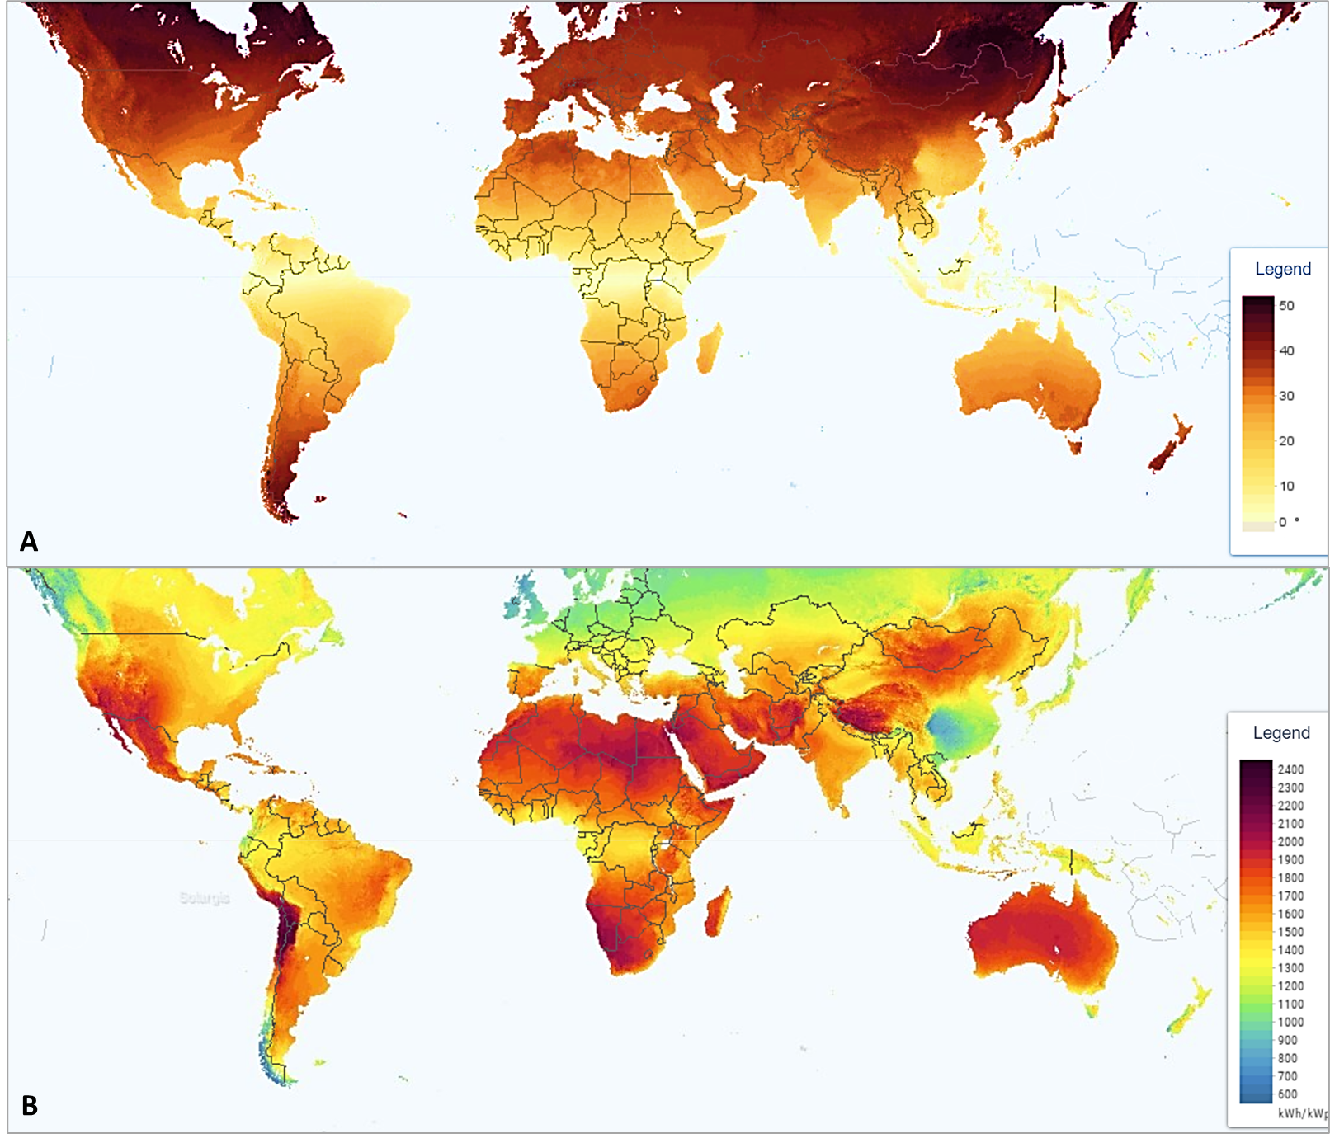

Figure 4: Map showing A) optimum tilt angle for solar panels with legend in degrees and B) estimated typical solar energy yield for solar panels in optimum fixed orientations but subject to landscape shading, local weather and atmospheric effects [16].

|  |  |  |  |  |  |
| --- | --- | --- | --- | --- | --- |
| **Sit location** | **Optimum Tilt Angle (°)** | **Azimuth (°)** | **Typical PV Energy Yield (kWh/kWp)** | **Elevation (m)** | **Air Temp. (°C)** |
| Penryn, UK | 36 | 180 | 1047.2 | 101 | 11.4 |
| Pittsburgh, USA | 32 | 180 | 1315.8 | 325 | 11.2 |
| Rockhampton, Australia | 25 | 0 | 1700.7 | 14 | 22.6 |
| Chennai, India | 14 | 180 | 1379.5 | 12 | 28.3 |

Table 1:

**Annual energy gain of solar PV technologies with Glasswing AR:**

As can be seen from Figures 5A-D for the shortlisted locations given in Table 1, the AR coatings give their greatest benefit at vertical installation tilts, for all orientations from East, through South to West. This is due to solar angle of incidences upon a vertical installation typically being much wider than horizontal or optimum tilts. This is most noticeable for locations closer to the equator such as Chennai, which will experience higher elevation angles of the sun. This is also why the optimum tilt angle for these locations is relatively low, close to horizontal, and hence the performance increase of the horizontal panels vs. the optimum tilt panels when incorporating the AR coatings is very similar.

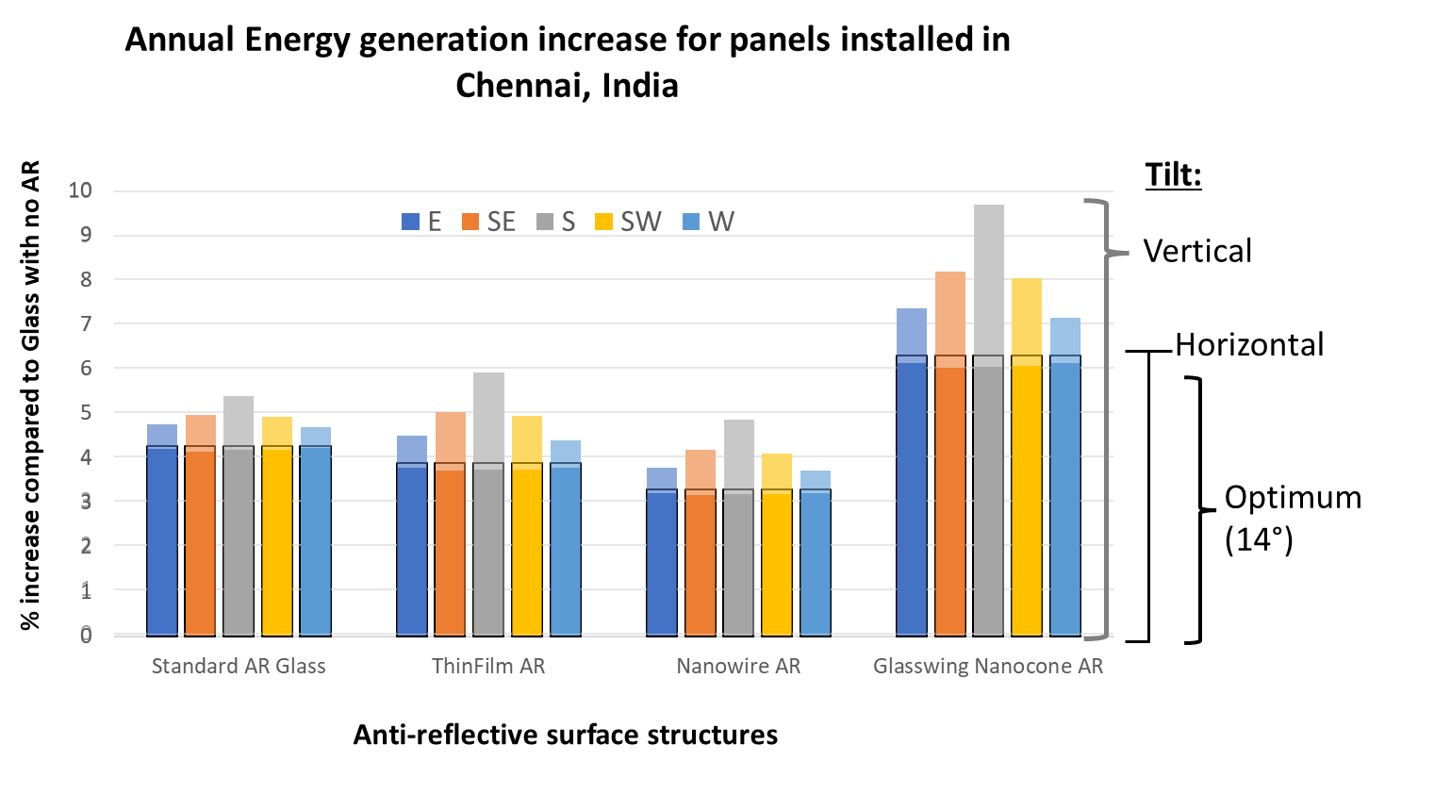

Fixed integrated systems will experience a range of incidence angles. For example, if in the northern hemisphere a system is installed vertically facing south, then only wide angles of incidence (AOI) will be experienced, and any efficiency gains at low angles will be ineffectual. Similarly, a horizontal panel will be exposed to increasingly wide AOI if installed at locations further from the equator.

**References**

[1] D. S. Renné, “Progress, opportunities and challenges of achieving net-zero emissions and 100% renewables,” *Solar Compass*, vol. 1, p. 100007, May 2022, doi: 10.1016/J.SOLCOM.2022.100007.

[2] HM Government, “Net Zero Strategy: Building Back Greener,” London, Oct. 2021.

[3] S. Teske, *Achieving the paris climate agreement goals: Global and regional 100% renewable energy scenarios with non-energy GHG pathways for +1.5°C and +2°C*. Springer International Publishing, 2019. doi: 10.1007/978-3-030-05843-2/COVER.

[4] Y. Sun, R. Wilson, H. Liu, and Y. Wu, “Numerical investigation of a smart window system with thermotropic Parallel Slat Transparent Insulation Material for building energy conservation and daylight autonomy,” *Build Environ*, vol. 203, p. 108048, Oct. 2021, doi: 10.1016/J.BUILDENV.2021.108048.

[5] K. Shanks *et al.*, “An experimental analysis of the optical, thermal and power to weight performance of plastic and glass optics with AR coatings for embedded CPV windows,” *Solar Energy Materials and Solar Cells*, vol. 200, p. 110027, Sep. 2019, doi: 10.1016/J.SOLMAT.2019.110027.

[6] K. Lee *et al.*, “The Development of Transparent Photovoltaics,” *Cell Rep Phys Sci*, vol. 1, no. 8, p. 100143, 2020, doi: 10.1016/j.xcrp.2020.100143.

[7] W. Zhang *et al.*, “Comprehensive analysis of electrical-optical performance and application potential for 3D concentrating photovoltaic window,” *Renew Energy*, vol. 189, pp. 369–382, Apr. 2022, doi: 10.1016/J.RENENE.2022.02.121.

[8] A. Sierra Rodriguez, T. de Santana, I. MacGill, N. J. Ekins-Daukes, and A. Reinders, “A feasibility study of solar PV-powered electric cars using an interdisciplinary modeling approach for the electricity balance, CO2 emissions, and economic aspects: The cases of The Netherlands, Norway, Brazil, and Australia,” *Progress in Photovoltaics: Research and Applications*, vol. 28, no. 6, pp. 517–532, Jun. 2020, doi: 10.1002/PIP.3202.

[9] D. F. Zambrano *et al.*, “Mechanical and microstructural properties of broadband anti-reflective TiO2/SiO2 coatings for photovoltaic applications fabricated by magnetron sputtering,” *Solar Energy Materials and Solar Cells*, vol. 220, p. 110841, Jan. 2021, doi: 10.1016/J.SOLMAT.2020.110841.

[10] R. Dewan, S. Fischer, V. B. Meyer-Rochow, Y. Özdemir, S. Hamraz, and D. Knipp, “Studying nanostructured nipple arrays of moth eye facets helps to design better thin film solar cells.,” *Bioinspir Biomim*, vol. 7, no. 1, p. 016003, Mar. 2012, doi: 10.1088/1748-3182/7/1/016003.

[11] Z. Han, Z. Jiao, S. Niu, and L. Ren, “Ascendant bioinspired antireflective materials: Opportunities and challenges coexist,” *Prog Mater Sci*, vol. 103, pp. 1–68, Jun. 2019, doi: 10.1016/J.PMATSCI.2019.01.004.

[12] M. Motamedi, M. E. Warkiani, and R. A. Taylor, “Transparent Surfaces Inspired by Nature,” *Adv Opt Mater*, vol. 6, no. 14, p. 1800091, Jul. 2018, doi: 10.1002/ADOM.201800091.

[13] S. Haghanifar, M. Mccourt, B. Cheng, J. Wuenschell, P. Ohodnicki, and P. W. Leu, “Creating glasswing butterfly-inspired durable antifogging superomniphobic supertransmissive, superclear nanostructured glass through Bayesian learning and optimization †,” *1632 | Mater. Horiz*, vol. 6, p. 1632, 2019, doi: 10.1039/c9mh00589g.

[14] R. H. Siddique, G. Gomard, and H. Hölscher, “The role of random nanostructures for the omnidirectional anti-reflection properties of the glasswing butterfly,” *Nat Commun*, vol. 6, p. 6909, 2015, doi: 10.1038/ncomms7909.

[15] D. G. Stavenga, “Thin Film and Multilayer Optics Cause Structural Colors of Many Insects and Birds,” *Mater Today Proc*, vol. 1, pp. 109–121, Jan. 2014, doi: 10.1016/J.MATPR.2014.09.007.

[16] Solargis s.r.o. on behalf of the World Bank Group, “Global Solar Atlas 2.0,” *a free, web-based application developed and operated with funding provided by the Energy Sector Management Assistance Program (ESMAP)*. https://globalsolaratlas.info (accessed Mar. 10, 2023).

**Supplementary information** is available in the online version of this paper.

**Acknowledgements** This work has been supported by EPSRC, UK, (Ref No: EP/J000345/1), and BBSRC grant BB/H014268. Authors acknowledge the funding agencies for the support.

**Author Contributions** R. ff-C, S.S., T.K.M and K.S. jointly conceived the study, the experiments therein and participated in manuscript preparation. K.S. performed all practical experimentation.

**Author Information** Correspondence and requests for materials should be addressed to R. ff-C ([rf222@exeter.ac.uk](mailto:rf222@exeter.ac.uk)) and T.K.M. ([T.K.Mallick@exeter.ac.uk](mailto:T.K.Mallick@exeter.ac.uk)).

**Figure 1 White butterflies as solar concentrators. a**, Photograph of small white with wings in ‘V-shape’ basking posture. **b,** Schematic diagram of theoretical light concentration towards thorax via reflection from wings of butterfly. **c,** Method for measuring wing angle effect on ‘body’ temperature (°C). **d,** Method for measuring wing angle effect on current output (mA) from solar cell in place of ‘body’.

**Figure 2 Thermal analysis of butterflies with wings held open (90°) or in a V-shape (17°).** **a,b**) Increase in temperature seen following 10 second exposure to one sun equivalent. **c,d**) 35 second exposure to one sun equivalent. Note the dramatic increase in temperature at the equivalent location of the thorax when the wings are held at the optimal basking angle of 17°. **e,** Graph of ‘body’ temperature as a function of wing angle for two sunlight exposure times of 10 seconds and 35 seconds.

**Figure 3 Mapping reflectance across the butterfly wing.** Average percentage reflectance map for wings of the large (**a**), small (**b**) and green-veined white (**c**) butterflies. Insets show how each wing appears in normal daylight. **d,e,f)** Reflectance spectrum for specific notable areas (maximum, minimum and black spot areas). Note how reflectance decreases dramatically over the black ‘spots’ present of the forewing of females of the large (d) and small white (e) whose black scales lack the reflecting pigment containing beads, see text for discussion. **g,** SEM of wing scale containing packed pterin beads. **h,** SEM of black spot area of wing scale containing significantly less pterin beads.

**Figure 4 Butterfly wings increase both the output power and the final power to weight ratio of solar cells. a**, Power output of an mono-crystalline silicon (Si) solar cell either alone, or with large white wings versus reflective film held at the optimal angle of 17°. **b**, Histogram representing the relative changes in both power, weight and the subsequent power to weight ratio of large white butterfly wings versus reflective film.